**CSS Basics**

**Overview**

Edit assignment2.html and style.css so the page looks similar to that shown in Figure 1.

**Instructions**

1. Create the form and position the elements by placing them within a table. While we do not believe that this is best practice, legacy sites often use tables for layout so it may be sensible to get some experience with this approach. In the next chapter, you will learn how to use CSS for layout as a better alternative.
2. For the drop-down lists, add a few sensible items to each list. For the checkbox list, they should be an array of elements. Notice also that this form makes use of a number of HTML5 form elements.

**Test**

1. Test the form in the browser. Because this form uses HTML5 input elements that are not supported by all browsers, be sure to test in more than one browser.

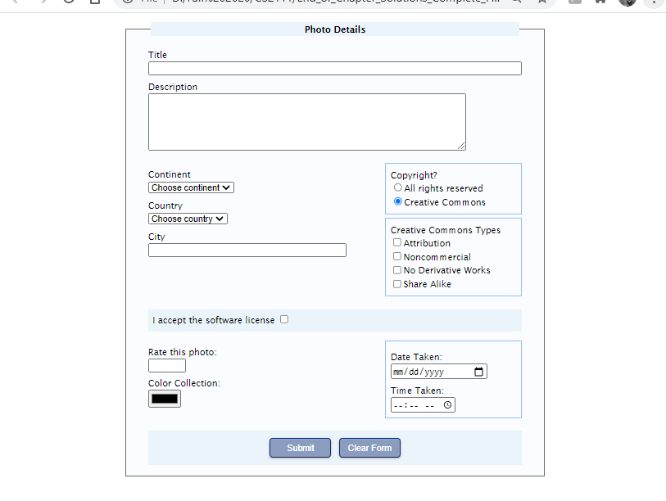

Figure 1 Completed Answer